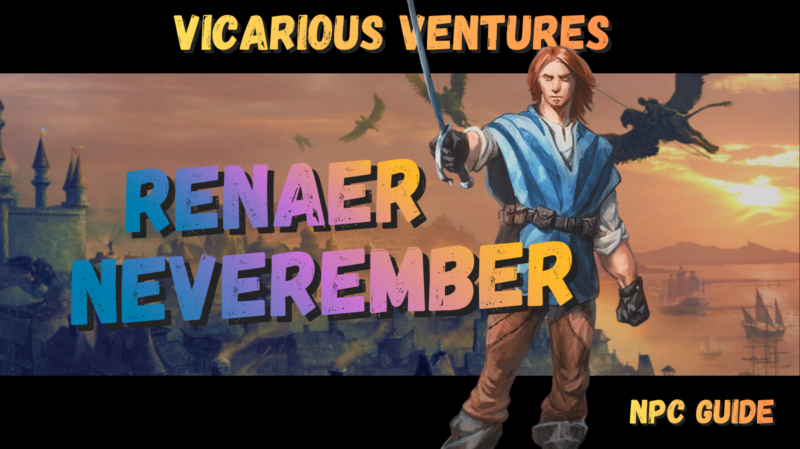
- Why is Renaer the most important NPC in your Grand Game
  - Why is he so useful?
  - If he’s so useful, why don’t DMs use him more?
  - The Dungeon Master’s Secret Weapon
  - Lord Never-Remember: Helping the PCs remember things
- Who is Renaer? His semi-tragic backstory.
  - Early Life and the friends who shaped him
  - The Brandath Bloodline
  - His Mother’s Mysterious and Tragic Death
  - The Shadow of his Father: The Neverember Bloodline
  - He’s a Swashbuckler
  - He’s a Rogue
  - Personality and Roleplay Tips (voice)
- Pre-Dragon Heist events from Blackstaff Tower and creating the new Moonstars
  - Teaming up with Meloon and Laelra to Rescue Vajra
  - Foreshadowing the location of the Vault of Dragons in the Brandath Mausoleum
- Current Relationships to Meloon, Vajra, and the Harpers (Mirt)
  - How to use Renaer with Meloon
  - How to use Renaer with Vajra
  - How to use Renaer with the Harpers
- Using Renaer to control the sandbox as a Walking Wikipedia
  - He’s a history buff, use that!
  - How to use his Wealth and Influence (Funding the Trollskull + Volo)
- Introducing Renaer in the Zhent Warehouse and using him as a sewer Guide
  - Hyping him up before introducing him so they trust him
  - Guiding the Party through the Sewers and the Floon Time Crunch
- Dhalakhar and The Fireball incident
  - Why is Dalakhar trying to meet with Renaer?
  - Homebrew: Dalakhar’s Letter
- Where Renaer lives + places he can be Found
  - Often checks in on the party at the Trollskull as their mentor and serves as the voice of the DM to fill them in on things (being scried for example)
  - Known Real Estate he owns (Roarke House and Brandarthall)
  - Yawning Portal or hanging out with Mirt
  - Great to feature at the Shipwright’s Ball
  - Great for the endgame battle when you need an extra party member for the numbers game
- Optional Spice: The Floon Romance and/or long lost brother
- Optional Spice: Dagult Neverember returns
- Custom Swashbuckler Stat Block

1.) Why Renaer is the Most Important NPC in Your Grand Game
If you are running Waterdeep: Dragon Heist using the Alexandrian Remix or any version of the “Grand Game” where multiple villain factions are competing for the Stone of Golorr, then Renaer (Reh-NAIR) Neverember becomes one of the most useful NPCs in the entire campaign. In fact, he might quietly be the most important NPC in the story who is not a villain. When your players are confused with all the factions, the game of thrones-esque alliances and double crosses and politicking, he’ll be there to guide them.
At first glance, Renaer seems like a minor character. He appears early in the adventure after being kidnapped by the Zhentarim and his friend is mistakenly targeted by the Xanathar Guild. After the party rescues his friend, Floon, he thanks the adventurers and helps them get established in Waterdeep. But behind the scenes, Renaer sits at the center of the Grand Game forming between the villains factions and any factions the players have allied with (Harpers, Gray Hands, Doom Raiders Zhents, etc). Renaer is a swiss army knife NPC.

Why is he so useful?
- His background as an adventurer makes him a good mentor and cheap item supplier and/or occasional sugar daddy rewarding players with magic items from his collection.
- His nobility, good social status, and high charisma gives him connections with anyone in the city.
- His skills as a swashbuckler can prevent the party from a TPK early on in the campaign.
- He has connections to the Harpers and can serve as a moral compass for the party’s more selfish members wishing to keep the treasure for themselves.
- His love for books and knowledge of Waterdhavian history makes him a wise advisor and can help the DM info dump in character without needing to break immersion.
- He's a real catch. He, Jarlaxle, and Davil Starsong make great romance options for players.
- His father is both the catalyst for the events of the main quest and he’s itching to right his wrongs and make up for the sins of his father.
- Most importantly, he introduces the Main Quest MacGuffins
As the son of Dagult Neverember - the disgraced former Open Lord of Waterdeep who embezzled half a million gold dragons and hid them somewhere in the city - he is caught up in the events of Dragon Heist from the beginning. Because of that connection, many people assume Renaer knows something about the missing gold, but that’s not entirely true.
It’s no secret his father embezzled money and was ousted by the Masked Lords of Waterdeep, but Renaer has no clue that Dagult stashed it in his mother’s family mausoleum (Brandath Crypts). Nor does he know that his father secretly left him with an Eye of Golorr in his mother’s locket (see the Alexandrian Remix for How the 3 eyes of Golorr work with the main Stone). But that does not stop the city’s criminal and political factions from circling him like sharks.

If he’s so useful, why don’t DMs not use him more?
There are two reasons he is slept on.
- No Official Guidance. The module doesn’t explain why he’s important or how he’s connected with Vajra, Meloon, or the Harpers. He’s just a guy who got wrapped up in his Dad’s schemes.
  - They also give no guidance for how to use Renaer and involve him as a companion for quests and/or a mentor role (we fix this, see below).
- Questionably introduced: Renaer is a rich pretty boy and everyone thinks he’s suspicious when they meet him in the warehouse, and have to take his word when he talks about his father’s scheming.
  - We will also fix this by highlighting how down-to-earth and trustworthy he is by seeing it early in the Yawning Portal and with others vouching for him
  - I also cannot overemphasize how important it is for Renaer to say how much he’s not like his father and explain he’s an adventurer like them (if a bit retired)

The Dungeon Master’s Secret Weapon
Running Dragon Heist as a sandbox can feel overwhelming for new DMs. Multiple villain factions are moving at once, clues are scattered across the city, the players can go almost anywhere but maybe they aren’t the best note takers. Or maybe you’ve got them so caught up in the Chapter 2 side quests that they forget all about the suspicious locket Renaer had something stolen from.
In my campaign I had Renaer help buy the Trollskull Manor from Volo to help the adventurers out, and this makes Renaer invest in their success as the next generation of Moonstars (even if they aren’t called that). Another bit of homebrew I implement is him introducing the players to factions and/or one of the Villains. When the players need the 1000+ gold dragons to repair the Trollskull Manor, he can introduce them to a fellow Harper, Mirt, and he can also introduce them to the bank-owning Casssalanters since he knows they can offer him a better loan option than the Mirt or the Zhentarim loan shark, Istrid Horn.
These early Chapter 2 seeds make sure the players are still interacting with the main players of the Grand Game (to solve Neverember’s Enigma and find the Golorr artifacts to find Dagult’s treasure in the Vault of the Dragon’s).
By the time Chapter 3 comes around and the fireball incident hits to kick off the rush for the stone, the players will already be deeper into the Grand Game factions than they realize.

Lord Never-Remember: Helping the PCs remember things
Let’s be honest, with the 100+ NPCs in Dragon Heist and the players never remember everything, and they often have questions their characters would like to ask without wasting time they could be questing by visiting the local library (especially if that’s “not what their character would do”. Enter Renaer; the “Walking Wikipedia of Waterdeep” to steer them in the right direction whenever they are feeling lost and/or actually off track.
Renaer has spent years walking the streets of the city, speaking with nobles, merchants, sailors, adventurers, and spies. He reads constantly and has a deep love of Waterdeep’s history.
That means he can naturally provide historical context, local rumors, connections between NPCs, advice about factions, warnings about dangerous players in the city and explaining the consequences of their rash actions (i.e. when my player used an invisible mage hand to steal the eye of Golorr
Importantly, he can do this in character, without the DM needing to break immersion. Suddenly the information feels like part of the story, not a DM reminder.

2.) Who is Renaer? His semi-tragic backstory.

Early Life and the friends who shaped him
Renaer is the quintessential unflappable Waterdhavian. He was almost certainly born and raised in Waterdeep. In Blackstaff Tower he has a halfling thief friend who says that they grew up together. Not much other information is canon regarding his childhood, but we can deduce he was a bit of a troublemaker and rebellious throughout his teen years - especially towards his father - until his heroic status is achieved in his twenties when the events of the Blackstaff Tower novel occur and he saves Vajra (See my Vajra guide here).
He has been looked after since childhood by Madrak Salibuck, a white-haired halfling butler who was a loyal servant to his mother. Madrak's son, Bramal, acts as Renaer's proxy in managing the family's extensive property holdings.

The Brandath Bloodline:
- Kulzar Brandath: Renaer's great-great-granduncle was a notorious pirate, a fact Renaer finds fascinating rather than shameful. Swashbuckling is in his blood.
  - Kulzar’s Alley near Roarke House was named after Kulzar, and beneath these streets lies his lost treasure. Not only was this lost because it was hidden in the underground passageways beneath this alley, but doubly so when the spellplague warped these passages likely sealing off any obvious ways to find it
- Varad Brandath: A more scholarly ancestor, Varad was one of the last students of the legendary Blackstaff, Khelben "Blackstaff" Arunsun. Varad built the family’s hidden mansion, Varadras, which is located outside of Waterdeep as a safehouse unbeknownst to Dagult. It was only known to his mother and Renaer, who accessed via a secret portal in Renaer's Sea Ward residence, Brandarthall (yes, it’s spelled with an R for some reason).
- The Brandath Mausoleum connects to a dwarven vault where Renaer stashed all of his stolen money, and this Vault of the Dragons is where the adventure of Dragon Heist ends.

His Mother’s Mysterious and Tragic Death
His mother, Alathea Brandath - from the ultra-wealthy Brandath Family - died when he was a young age. It's never specified how exactly she died though it was likely due to an illness, though it must have been a tragic death that left a deep wound on Renaer. Why was her death tragic?
Well, her husband only married her for her money, but it may be going too far - even for the Dastardly Dagult - to have killed his wife just to inherit her money and real estate. Though he was known to poison his enemies with drugged wine he kept in his vaults, so he very well could have made it look like an accident quite easily.
If this was his plan, however, it would have backfired spectacularly when his mother left everything to Renaer, leaving absolutely nothing to Dagult. It can therefore be assumed that they had a rocky marriage and she hated Dagult once she got to know him behind closed doors.
You may also wonder why one of the most important women in Faerun wouldn’t have Life Insurance (as in, a resurrection spell cast on her). There are only 3 options that make sense here.
- She died from a curse that greater restoration could not heal
  - Perhaps she came upon a cursed item amongst Dagult’s infamous horde of secret powerful magic items
- Her body was disintegrated or unrecoverable and/or lost
  - She was lost at sea or attacked by something powerful like a Beholder (they do have a disintegration beam) or a Mind Flayer devoured her brain
- The darkest option, which should be exercised with caution, is that she took her own life due to the depression from marrying Dagult and she did not wish to be brought back
  - Definitely check with your table BEFORE you introduce this element and use safety tools if someone becomes uncomfortable with this topic
  - She may also have died from an accident or illness and her soul was not willing to return due to her own religious beliefs and/or dissatisfaction with her life

The Shadow of his Father: The Neverember Bloodline
I discuss Renaer’s Neverember lineage more in the Dagult guide, which is a companion to this one. The important thing to note is that the Neverembers (despite having a name that sounds just like Neverwinter) are not direct descendents of the original kings of Neverwinter, but Dagult has forged documents that make him look to be a legitimate descendant of the crown. Publicly Dagult is the steward of Neverwinter, claiming he’ll step aside if the rightful heir ever surfaces. But privately he’ll never do this, and this can be a weak point with Dagult since he could be exposed as a fraud if he is caught preventing a true heir from returning.
The Neverember family is actually still a very well respected family and despite Dagult being a real bastard, his ancestors seemed to have some level of honor. It is mentioned in the Blackstaff Tower that Dagult possesses a magic sword that he cannot draw and wield because it wouldn't acknowledge him as worthy to wield it as his ancestors did. This could mean that Renaer could instead inherit this sword and get a major upgrade from his basket-hilted rapier. (See his upgraded stat block for my suggested homebrewed sword when he confronts his father and claims the sword as his).
One item that neither Renaer nor his father can wear is the Crown of Neverwinter. It will only allow the direct bloodline of the kings (the Alagondar family) of Neverwinter to wear it, else they will die from an explosion of heat and cold damage. This is why Dagult is only the Lord Protector of Neverwinter and not the king of Neverwinter.
Weirdly enough, despite being ousted by the Lords of Waterdeep while he was gone, Dagult Neverember is still well liked outside of Waterdeep and even attends the Lords Alliance meetings as ruler of Neverwinter. Renaer is therefore in an awkward position at the start of Dragon Heist, since it's probably a coin flip whether the lay people of Waterdeep recognize him for his own merit or lump him in with his scandalous father. Everyone who actually knows Renaer knows he’s a good guy and some even know him as a hero.

He's a Swashbuckler
Although it is never mentioned whether or not he has sailed with a crew, he is listed as a swashbuckler in his stat block and one his best friends, Faxhal, was a chivalrous noble some sailing experience; such that Renaer prayed to the sailor god Valkur at one point in the novel on his behalf. Given the seminal importance of the Deepwater Harbor and Waterdeep's pride as a global trade hub, any Waterdhavian worth their salt would have an interest in learning to sail and know their way around the docks and harbor.
It is for this reason I'd recommend homebrewing some tales of Renaer sharpening his sword skills as a somewhat privileged privateer aboard a vessel in the Waterdhavian Navy, if only to get away from his father.

He's a Rogue
Learned sleight of hand and sneaking from his halfling friend Osco, and learned he had a knack for cunnish dashes through the city to avoid the City Watch whenever his troublemaking and vigilantism caught up to him.
He has excellent sword skills with his basket-hilted sword (Renaer’s Rapier, as I call it). See Renaer’s scaled stat block(s) for some cool roguish tricks he can do (besides just sneak attack) such as goading his enemy and swashbuckling

3.) Pre-Dragon Heist events from Blackstaff Tower and creating the new Moonstars

Teaming up with Meloon and Laelra to Rescue Vajra
In 1479 - 13 years before the events of Dragon Heist - a young Renaer got caught up in a plot to take over Blackstaff Tower when the previous Blackstaff was assassinated and his heir, Vajra, was kidnapped and tortured. A young sorceress from the Cellarers and Plumbers named Laelera (not to be confused with Laeral Silverhand) recruited Meloon Wardragon to investigate, leading them to discover Vajra's whereabouts in the sewers beneath one of the many properties Renaer owned, the Roarke house (near the Heroes Garden in Sea Ward).
After rescuing Vajra and helping her take her place as the new Blackstaff, Renaer and Meloon all became good friends and formed a new generation of Moonstars, since the previous generation of them had all been wiped out (they originally served the original Blackstaff and were formed by him and his wife, Laeral Silverhand).
There were several other members of the Moonstars but they are not mentioned in Dragon Heist. We can assume that some (like the forged item maker Parlek Lateriff are still in the city, and the others may or may not have gone on their own adventurers.
If you do want to use them, their meeting place is at the Roarke House. In my campaign I elected to make Remaer “retired” as an adventurer and therefore the Moonstars are either disbanded or have moved their headquarters elsewhere.
Renaer is still good friends with Meloon <link to guides here> and Vajra, though the former is now an intellect devourer and the latter is too busy to see him much.
Note: If you'd like to see what facts can be gleaned from the Blackstaff Tower novel and the new Moonstars, see my video here on my Patreon. It does not cover the events of the novel itself, but rather what can be learned about Renaer, Meloon, and Vajra and Waterdeep lore.

The New Moonstars
At the end of Blackstaff Tower, Renaer converts Roarke House into the base of a new group of next-gen Moonstars to serve as heroes of the city, serving Blackstaff as vigilantes rather than members of the Watchful Order of Magists per se. He suggests they don’t have to refer to them as Moonstars, but he wants them to be like the old Moonstars group that served Khelben to protect Waterdeep. The first members of this group included Renaer, Vajra, Laraelra, Meloon, Renaer’s friend Toryln Wands, and Eiruk Weskur.
It’s unknown what happened to this group, but Vajra does have Force Grey as her elite adventurers who serve the larger Gray Hands faction. Renaer’s Moonstars could have been absorbed into this group, they may have remained secretly independent, or they may have simply dissolved. It is up to you as the DM whether they are still operational, and I would recommend leaving them easily revivable if Renaer wants the PCs to become the successors to his group.

Personality and Roleplay Tips (voice)
I gave Renaer a proper upper crust noble accent (a British received pronunciation) that shows he’s well-educated and well-read, but try to keep him as genuine and down to earth as possible. Be very careful not to make him sound cocky or stuck up, otherwise the players will not like him and see him as a pretty rich boy and not as a valuable ally.
Renaer’s key traits are:
Talented, Heroic, Genuine, Affable, Well-read/Scholarly, Lawful Good that flirts with Chaotic Good, Maverick, Dashing, Unpretentious, Gregarious, Authentic.
His traits as a direct result of his father being a jerk:
Rebellious, Altruistic, Principled / Incorruptable, Anti-authoritarian/ Egalitarian.

The Low-Key Harper Operative
While Renaer lives off his mother’s sizable inheritance and often spends his time in taverns, he is a dedicated member of the Harpers but not as active as he used to be, likely due to him not seeing eye to eye with Mirt, who he sees as self-indulgence and tends to use his operatives however he pleases with questionable methods. He works closely with other high-ranking members like Mirt the Moneylender and Remallia "Remi" Haventree. Unlike his father, Renaer uses his position to defend Waterdavians against those who would deprive them of their rights.
If the players show promise as spies or "good bets," Renaer will be the one to pass their names to Mirt, often facilitating their first meeting through high-society events like the opera at Seven Masks Theater.

4.) Current Relationships to Meloon, Vajra, and the Harpers

How to use Renaer with Meloon
Renaer considers Meloon Wardragon a dear friend and a brother-in-arms, having adventured with him during the rescue of Vajra.. Meloon, after acquiring the legendary magic axe Azuregde, continued to gain renown and eventually became known as the Champion of Waterdeep. In Renaer’s eyes, Meloon is the "honest, optimistic, and extraordinarily lucky" hero of the North. So naturally, Meloon’s sudden strange behavior has him alarmed. Because Renaer is so close to Meloon, he (and by extension the Harpers) is among the first (besides Vajra) to notice that Meloon’s “happy-go-lucky” demeanor has soured. As the campaign progresses Vajra asks the players to look into Meloon’s behavior, have Renaer check in with the party while that quest is active and they have verified Meloon’s behavior.
In our campaign I had Renaer really get a first-hand glimpse of Meloon’s new personality when they were aboard the Shipwright’s Ball (see my guide here) where Meloon’s cockiness, drunkenness, and rudeness has Renaer getting into an argument with him as Meloon tells him to buzz off.
What follows is up to you as the DM, but I would have the players confront Meloon directly in what could come to a combat encounter. If Renaer is present he can help prevent a TPK since Meloon is very strong, especially if he makes his save that day to use the power of Azuredge despite being an intellect devourer. A good place to do this might be in the Court of the White Bull, as I mentioned in my Meloon Guide.
My personal choice was to have Renaer serve as the coach for the party in the Gladiator Games of the Field of Triumph, where they face off against Meloon’s team and Renaer can confirm that he’s no longer himself.

How to use Renaer with Vajra
Because Vajra owes her life to Renaer, he is held in high regard by her. If the players wish to speak with Vajra about major events (such as Manshoon returning or finding the dragon Zelifarn) he can help them skip the line and arrange to see her immediately.
Vajra can then offer the players entry into the Gray Hands faction and upon completion of their first mission (investigating Meloon) they can become her elite special forces operatives as members of Force Gray. She can give them a badge and everything, and Renaer may even give them a Moonstar ring.
Renaer might even ask the players to become the new members of the Moonstars 3.0, the third generation of adventurers who swear to protect the city and serve the Blackstaff using the Roarke House as their secret hideout.

How to use Renaer with the Harpers
This is a tricky one because it depends on you as the DM to consider these points:
- How retired and/or jaded about adventuring is Renaer?
- What is the current status of his next-gen Moonstars that he formed at the end of BT?
- Is Renaer a passive member of the Harpers or an active member?
No matter whether the players are interested in becoming the next generation of Moonstars, he is interested in sponsoring them, providing them a meeting place - Roarke House - if the Trollskull Manor is compromised in security, and connecting them with other Harpers like Mirt and Mattrem “Threestrings” Marig (who Renaer probably knows well enough to call Matt.
Mirt’s epithets as “the moneylender” and the “merciless” do not resonant with Renaer’s altruism, and for that reason I think he would butt heads with Mirt’s self-centered nature and his morally flexible allowance of Harpers to enact their vigilantism as they deem fit.
Mirt is a well-seasoned adventurer though and will be chomping at the bit to both get Renaer to come out of retirement (asking him repeatedly John Wick-style if he is “back” to working as an adventurer) and even more so, will want to recruit the party as Harpers as soon as they’ve proven themself. If they haven’t done an optional 3rd party quest such as the Blue Alley for Mirt, Mirt will try (likely at the Shipwright’s Ball or simply at the Yawning Portal when convenient) to get Renaer to come out of retirement and have the party become Harpers so they can fight against this growing network of spies that he has heard about threatening the city (the Bregan D’aerthe).
If the party convinces Renaer to come out of retirement he will give them access to his secret weapon cache (cue John Wick sledgehammer scene) in Roarke House and Mirt will give them the remaining Harper faction quests. If they do well they can become direct servants to Mirt’s Harper superior officer, Remalia Haventree who can also be introduced by Renaer or Mirt at the Ball.

5.) Using Renaer to control the sandbox

He’s a History Buff, use that!
If there's one thing I learned about Renaer in the Blackstaff Tower novel, it's that Renaer is a huge nerd. One of his favorite hobbies is collecting rare tomes, and he is a huge history buff. When you want to explain things about Waterdeep, don't rely on your party's terrible history checks, that'll just slow you down. Use Renaer as a Watedhavian Wikipedia to tell them where to find the best spots in the city for whatever task they are working on, as well as the scoop on any guildsman and/or lords of the city (masked lords may require a history check on Renaer’s half though, since those are supposed to be secret titles). Renaer's father represents the upper crust of the merchant's class, so he should be well connected with any mercantile activities in the city as well.

How to use his Wealth and Influence (Funding the Trollskull + Volo)
Renaer owns more real estate than anyone in Waterdeep. All of these holdings were left by his late mother, Alathea Branath, and not a single one of these properties is actually held by Dagult (she left Dagult nothing).
Therefore when Volo comes up short on payment to the adventurers for rescuing Floon, I had Renaer promise that he'd work something out with Volo.
When the players awoke the next morning in the Yawning Portal, they find out that Renaer has offered to help buy Volo's house at a deep discount. Yes, it is haunted but the location makes it a prime piece of real estate.
It is not suspicious for someone like Renaer to want to buy such a risky investment and Renaer does this because he believes in the party and wishes to be their temporary patron and long-term mentor.

Connections to other important NPCs
Renaer knows a LOT of people, and can tie a lot of NPCs together (especially recommended if you aren’t using Gale as per instructed in my Gale of Waterdeep Guide).
You should have Renaer stop by pretty much every day to check in on the party and see how their adventurers are going and help guide them, answer questions about Waterdeep, and most importantly point them in the direction of several NPCs they can talk to.
The largest confluence of NPCs that will occur in the campaign is at the Shipwright’s Ball, and this is an excellent place for Renaer to introduce any and all remaining contacts to the players that they haven’t engaged with.

6.) Introducing Renaer in the Zhent Warehouse and using him as a sewer Guide

Hyping him up before introducing him so they trust him
There are 2 problems with the way they introduce Renaer.
- He’s forgotten past Finding Floon
- He’s not immediately likeable
  - He’s introduced in a suspicious way
  - Players might have a hard time relating to him
  - They don’t realize he can be their patron
To the first point: Renaer is used as an introduction to the Stone of Golorr MacGuffin and then cast aside. He is hardly mentioned in the module again until the party needs to get access to his mother’s family mausoleum to get into the Vault of the Dragons. By then they’ll be like “Huh? Who was that guy again?”.
The other problem is that he is introduced in a shady Zhentarim warehouse in the place of a guy you were looking for. The place has been taken over by Kenku ambushers who are loyal to the Xanathar and this guy pops out claiming he was being held hostage and was hiding from the kenku. Heck he can even help them find Floon, all they have to do is trust him. This isn’t super difficult to handle with some insight checks and some history checks on Renaer as a Moonstar and his estranged relationship with his father, but if you don’t put that extra effort to explain who he is (via his dialogue about hating his father and the checks) they might already have their guard up with him.
And then there’s the elephant in the room; Renaer is a rich pretty boy noble (the fancy accent might also make him sound posh and supercilious) and they don’t want him cramping their style. This is where we need to drive home the fact that he was an adventurer just like them, he like recruiting and sponsoring up and coming adventurers, and his goals align with theirs (be it money, power, revenge against the Xanathar, etc). Him mentioning early on that he is not only willing to sponsor adventurers, but he can pay better than Volo (later helping them buy Trollskull from Volo) will give them an incentive early on to want to get on his good side.
If you want, you can even set up some lore related to Renaer earlier by having Meloon talk highly of Renaer at the Yawning Portal. Intellect devoured or not, “Meloon” would brag about knowing Renaer since he and Renaer are somewhat famous as heroes. You can also have Volo mention that he saw Renaer at the Skewered Dragon on his way out of the bar and that Renaer might know where Floon is. Volo can tell the party some gossip about Renaer and his dad, only to point out Renaer is nothing like his father and they can trust him.

Guiding the Party through the Sewers and the Floon Time Crunch
In our campaign, Renaer keeps the party pushing forward past any of the sewer fights because he assures them Floon will be dead by morning if they don’t press on. This ticking time clock prevents them from abusing the long rest mechanic and making fights too easy. Of course, in exchange for the party’s help Renaer is immediately helpful by directing the party through the sewers and preventing them from getting TPK’d by all of the classic sewer monsters (hello, Gelatinous Cube, Ghoul-Aid Man, Shadow Monk Mutant Tortles, Kevan’s Kobolds, Giant Gingerbread Golem, Gollum the troglodyte, etc).
He then helps them in the fight versus the Mind Flayer, helping them avoid getting TPK’d by giving his expert advice on fighting th monster they encounter and of course helping to carry Floon when they find him in Nihiloor’s lair.
I also had Renaer gift one of his Moonstar rings to the party, which upon being exposed to moonlight each night allows 1 creature to remove a level of exhaustion immediately, which he uses on Floon to help him recover from being tortured. They might also need this ring in case they are exhausted from all of these sewer encounters.

7.) Dhalakhar and The Fireball incident

Why is Dalakhar trying to meet with Renaer?
Dalakhar, on a mission from an irritated Dagult, has successfully stolen the stone of Golorr from the Xanathar Guild but has been unable to shake operatives pursuing him while he tries to lie low and lick his wounds. With several factions (Gralhunds, Manshoon Zhentarim and the Xanathar) on his tail, he tries to contact Renaer to help him escape the city, or at the very least keep the stone safe. He has heard of Renaer’s kidnapping via the Waterdeep Wazoo and it mentions he was saved by an upcoming group of adventurers and (mentioned by the article or not) has heard he has become their patron and can be found at the Trollskull as of late. Rather than risk an attack at Brandarthall, he writes a letter on a Paper Bird and sends it to Renaer, and heads to Trollskull hoping to set up a meeting with him there.

Homebrew: Dalakhar’s Letter
In our campaign, I didn’t want to leave it up to chance that the party to try to speak with dead on Dalakhar’s corpse (despite giving them a speak with the dead scroll). Instead, Renaer shows up shortly after the Fireball incident happens (and Barnibus asks them questions at the their house) and quietly asks the party to speak with them privately in Trollskull where he explains how he knew who the gnome was and that he was trying to meet with him which is why he was heading towards their house in the first place.
Here you can have Renaer tell them that they can use speak with the dead on his corpse once the watch is done with their investigation, but if they are reluctant to mess with the law enforcement or are chomping at the bit to go look for the nimblewright, I would reveal that Renaer has a paper bird message that Dhalakhar sent to him the previous night or early morning. You could also have it be something the players found on his body if they did an investigation check at the scene of the crime. If you they do, just add this part at the beginning:
"If you’re reading this, I’ve either been sloppy or unlucky. Probably both. Gods, I hope you found this before anyone else did.”
Here’s the letter, hastily scribbled as if he was in a hurry:
My Lord Renaer,
I took something. Something your father entrusted me to protect long ago. A relic. Dangerous. Something your father went to extreme lengths to keep secret.
They call it the Stone of Golorr. It isn’t just an artifact. It’s a key. It is somehow related to your father’s treasure. The one he kept when the city cast him aside, after all that he did for this city and for the New Neverwinter project, the Lords Alliance spat in the wind and this is their blowback.
I stole the stone from beneath the city from the monster’s lair itself. I could feel his eyes on me as I ran, the Xanathar. They've been chasing me ever since. He is but one of many players in a Grand Game that is forming between him, his rivals, possibly others. Remember there are enemies among us and trust no one in this blasted city.
I dare not approach Brandarthall nor the Roarke House. I heard about your new friends. The ones who pulled you from that Zhent warehouse. I will meet you at their residence in Trollskull Alley.
You always had a good head on your shoulders, even when you were sneaking past Madrak for midnight sweets…Remember what I taught you, boy. Stay in the shadows. Trust your instincts. Don’t play the hero, play smart. You may not like it but you've got your father's cunning and you're still a noble at heart. Whatever you do... don’t let the Stone fall back into the wrong hands. You know which ones I mean.
—D.
DM Note: Madrak Salibuck is Renaer’s old halfling butler who helped raise him. More on Madrak can be found in Blackstaff Tower.

8.) Where Renaer lives + Places he can be Found
As mentioned before, Renaer often checks in on the party at the Trollskull as their mentor and serves as the voice of the DM to fill them in on things (being scried for example), so this is the main place Renaer will be featured. However, it is a little known fact that - after his mother died and left him everything - he owns more Real Estate than anyone in Waterdeep.
The primary location I used outside of Renaer’s home in Brandarthall was the Roarke House. However, if the party needs to flee Waterdeep there is a secret rooftop garden with a statue that can teleport them out of the city. This is also a cool location to feature if you want to introduce the party to Renaer’s only remaining parental figure (Dagult doesn’t count), his halfling butler Madrak.
There is nothing in the adventure module detailing these locations but you can find these excellent community map for Brandarthall and Roarke House (Sadly no maps exist for this…yet! I might be making one soon as a Patreon release if there’s enough interest).
Even if you can’t use Roarke House per se, you can always have them hangout in Kulzar’s Alley and/or the Heroes Garden which are all in that area.
And of course, the final location Renaer can be found is at the Yawning Portal and/or hanging out with Mirt (possibly in Mirt’s Mansion) and Mattrig discussion Harper's business.
Other locations Renaer can be found are the Temple of Lathander known as The Spires of the Morning where he visits a traumatized and/or recovering Floon, and Renaer volunteers in the City of the Dead to honor his mother’s memory as well as lays flowers at her grave in the Brandath crypts, which could be a great easter egg foreshadowing the importance of it later so the PCs feel like the Vault was right under their noses.

9.) Optional Spice: The Floon Romance and/or long lost brother
It’s established that Renaer looks a lot like Floon, after all this is the reason Manshoon’s Zhentarim kidnappers took Floon instead of him in the first place. Both of them are good looking guys, so it’s plausible that they are related to each other as long lost brothers, and this is extra plausible since Dagult was a known womanizer and a flirt. He also had an affair with Kelain recently, so it’s been established he is a cheater and therefore it makes sense he would have a bastard son named Floon who he kept hidden from Alathea for obvious reasons.
The second option is a bit spicier, and I’ll admit this one is a bit of a stretch, but if you want Renaer to secretly be in a romance with Floon, that could also be another reason why Renaer is desperate to get to Floon in the first chapter. This would need to be a secret romance, not necessarily because Renaer is ashamed of his sexual orientation but the fact that Floon is an escort and therefore not “worthy” of being with a noble like Renaer. It could also be that Renaer doesn’t feel the same way that Floon does, but Floon loves him and Renaer knows that Floon would do the same for him in order to rescue Renaer if Renaer was ever kidnapped.
With whatever option you choose, adding the Floon secret reveal at the end of the campaign can add a fun twist to your story. Personally, I would recommend letting your players form their own theories about Floon and then whatever they guess, have that be confirmed as true at the end of the campaign so they can do the whole “I knew it! / I called it” at the end.

10.) Optional Spice: Dagult Neverember returns
This is explained in greater detail in my companion guide, the Guide to Dagult Neverember (link soon) but the gist of it this:
After hearing that Dhalakhar has failed his mission, Dagult is furious and leaves his machinations in place for the New Neverwinter moves and expeditiously arrives in Waterdeep. He may have been ousted from the city but he still has connections. And not to mention if the party has earned the ire of a noble house participating in the Grand Game, such as the Gralhunds or Cassalanters, they also may have reached out to him in desperation to form a tenuous alliance.
At the Vault of the Dragons, once the players have made it past the Vault Door and past the obstacles in their way, Dagult, his personal; guard, and his noble co-conspirators (the Cassalanters and their cultists or the Gralhunds and mercenaries) show up to stop the party from stealing what is “righftully” Dagult’s.
If the party has brought Renaer he can try to convince Dagult to walk away or call of his personal Neverember guards and make the battle easier or he can even challenge his father to a duel and win the NeverSword from him.
For more details see my Dagult Neverember guide.

11.) Changes to Swashbuckler Stat Block and Leveling Renaer up
When the party first meets Renaer he is higher level than them, but he not at the time of game given that he has a level of exhaustion from being interrogated by the Zhentarim, recovering from a hangover, and admittedly a bit rusty from not having fought in a while.
However as the party progresses he comes more and more out of retirement until he has his John Wick-esque “I'm back” moment. He busts out his old adventuring gear that gives him boosts to his stat block and several new abilities unlock.
Mechanically we want Renaer to feel similar in power level to the party by the end of the campaign.
In the module it recommends having the campaign end at Level 5, so he should at least feel on par with that.
However, if you wish for the party to level up higher so they can take on one of the Villains in a fight, an even stronger Renaer can be used for adventures Level 6 - 10.
I've included 2 stat blocks for Renaer, one to use past the first chain of events (past Chapter 1), and another one to use when the party is ready to take on the BBEGs when he has his full loadout of magic items. These will be referred to as Renaer (Well Rested) and Renaer (Fully Loaded).
Renaer (Vanilla, as found in Dragon Heist)
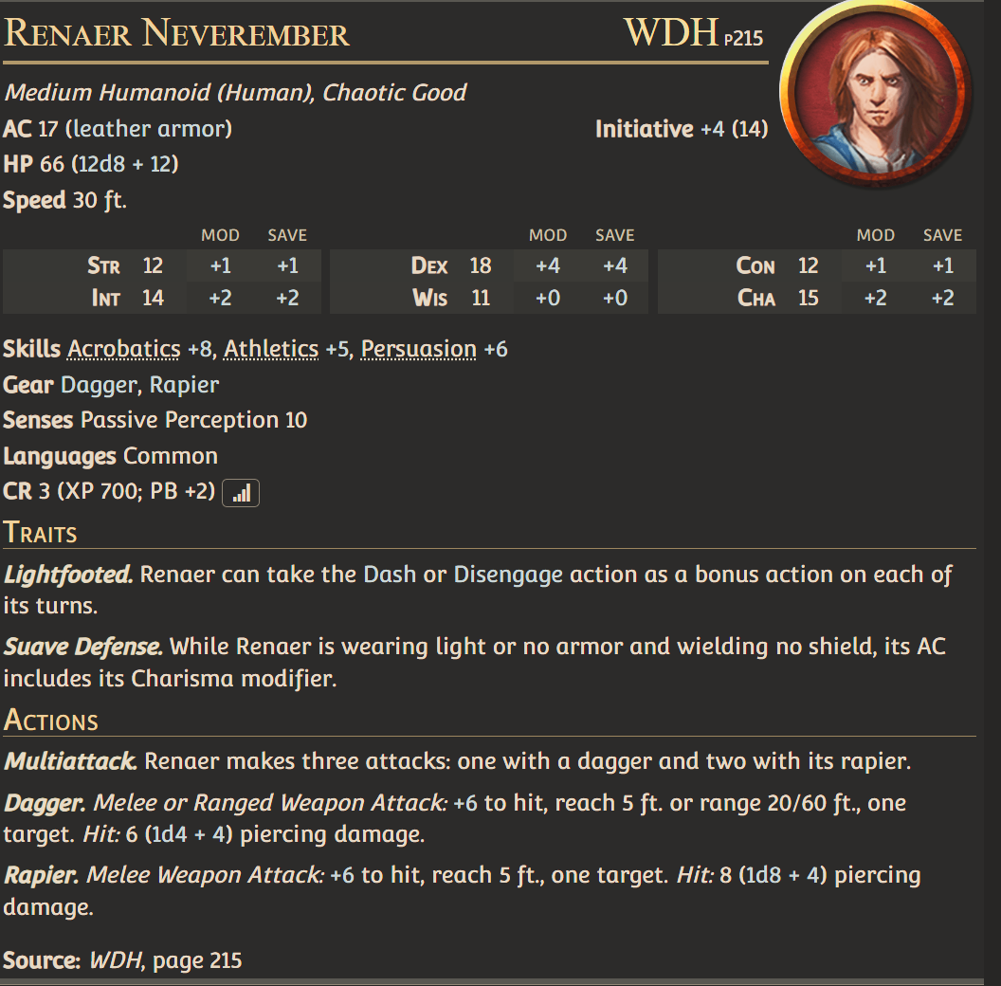
Renaer (Well Rested)
In addition Light-footed (basically Cunning Action Dash and Cunning Action Disengage), Renaer gains Sneak Attack (add 2d6) and can use Disarming Attack and Goading Attack Battle Master Maneuvers.
(Note: He can teach these maneuvers to a party member on a Long Rest with a DC 10 for a Martial and a DC 15 for a non Martial class, with the DC dropping by 2 each time they attempt to learn it).
He also gains the second half of the Rakish Audacity Swashbuckler subclass feature, meaning he can perform Sneak Attack when there are no other hostile creatures adjacent to his target.
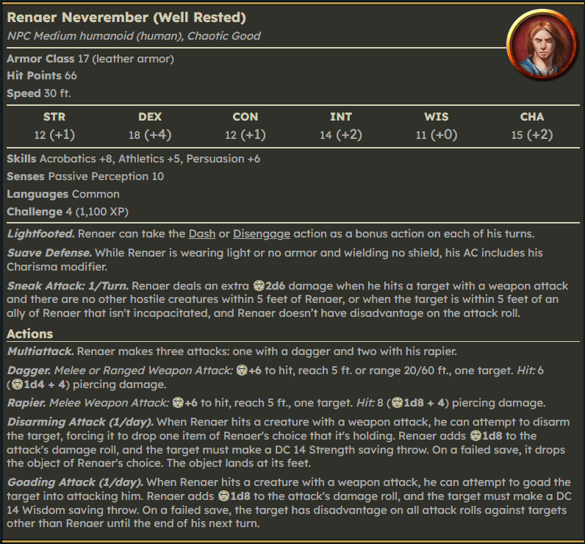
Renaer (Fully Loaded)
- He wields a +2 rapier and it gains the Vex weapon mastery.
- His sneak attack becomes 3d6.
- He gains “Yeah I’m thinking I’m back”
- He might also optionally giant the NeverSword and other magic items at DM’s discretion
“Yeah, I'm thinking I'm Back!”
Once per short rest, Renaer can use the fighter class’s Second Wind as a Bonus Action to recover 2d10 HP. This can also be used on an ally as he says something inspirational to them.
“Whenever you hit a target with a Vex weapon, you gain advantage on your next attack roll against that same target.”
Basic Tactics:
- Renaer can use his Moonstar Ring to help a player recover from one level of exhaustion.
- Play Renaer just like you would for a swashbuckling rogue.

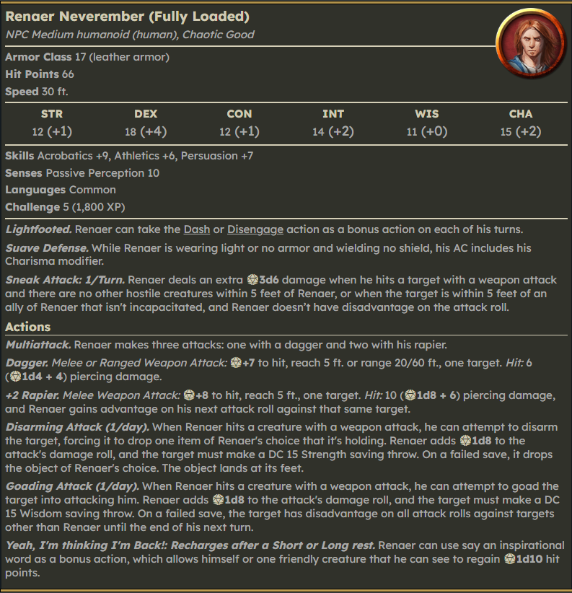

Optional Legendary Item:

You can also choose to have Renaer confront his father in the endgame (if you have Dagult show up at the Vault of Dragons, they fight a 1-on-1 duel while the party fights the BBEG). If he does stop his father, he claims from what I am dubbing the “NeverSword” from his father - the unnamed family heirloom sword that his father kept at his side but cannot use - because he is not worthy.

This NeverSword is Legendary +2 lawful good sentient magic sword and can be used in negotiations to charm and/or aid in persuasion checks with enemies and can cast Zone of Truth once per day at Dawn.

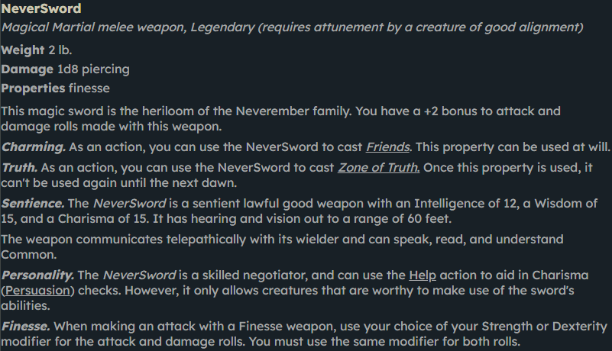

(Credit: Thanks to Browncoat Jayson for making images of these stat blocks and NeverSword for everyone to use 🫡)

